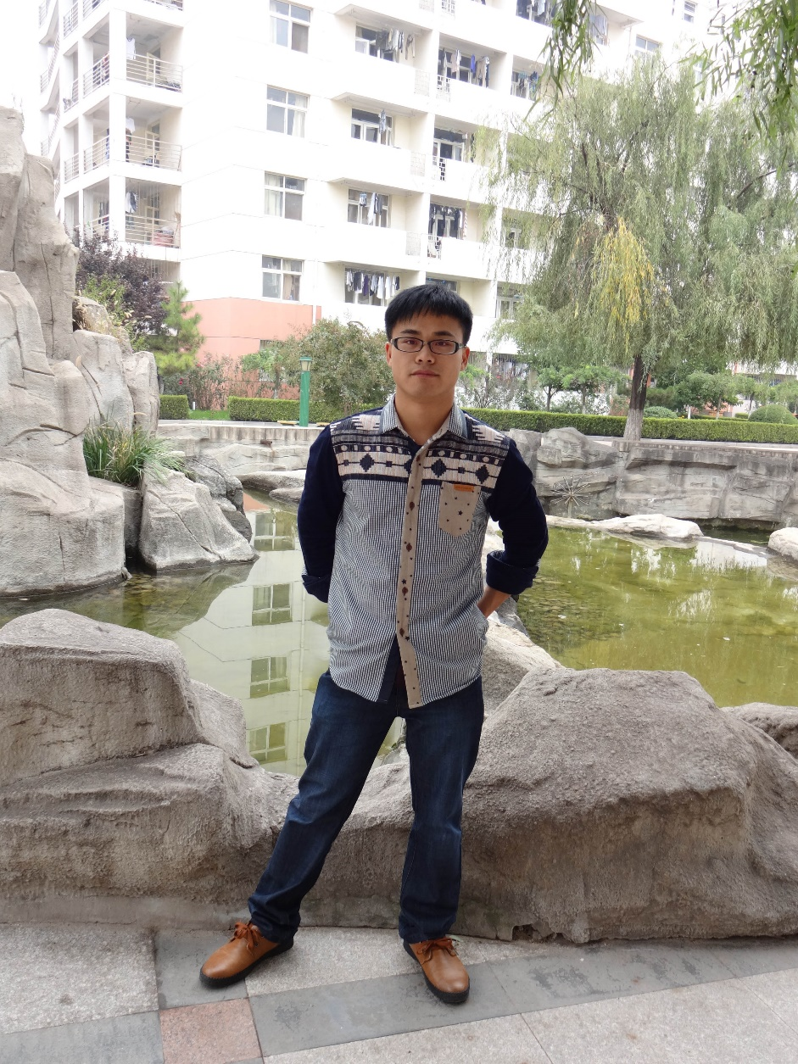

Li-Jun Xiao was born in 1989 and grew up in ZhuZhou of Hunan province in China. He obtained his B.S. degree in China Pharmaceutical University in 2012. Then he moved to the State Key Laboratory of Elemento-Organic Chemistry in Nankai Universty for the doctoral study under the supervision of Prof. Qi-Lin Zhou, focusing on transition-metal catalyzed new reactions for selective C−C bond formation, such as Ni-catalyzed selective coupling reactions between alkenes with aldehydes and imines through atom-economical process. While at SKLEOC of Nankai, he developed an interest in organic chemistry, and he is ready to make a plan for continuous study in this area after completing his Ph.D. in 2017. In his spare time, Xiao enjoys swimming, traveling, playing badminton and spending time with his friends and family.

E-mail: 1120140207@mail.nankai.edu.cn